1. Company Name

* Nexie Labs (Pvt) Ltd, group ID: 29 (or 30, not sure)

1. Meet our team

* Team Members

1. Content
2. What is KM?

* Process of creating, sharing, using and managing the knowledge and information of an organization.
* A multidisciplinary approach to achieve organizational objectives by making the best use of knowledge.

1. Introduction

* Nexie Labs (Pvt) Ltd, an IT services provider, extends its services through means of digitalization.
* Enriched with a comprehensive suite of novel tech solutions to cater out the digital perspectives of market individuals.
* Through the constant development of digital and technological standards, excels its services in digital marketing, web designing and development, work automation and warehouse management.
* Ultimate objective is to apply KM practices to develop a document management system for Nexie Labs evaluating the existing organizational infrastructure and knowledge capital of this organization.
* And align suitable KM and business strategy to add value to the organizational success and well-being.

1. Existing infrastructure facilities

* Mainly, they have used software’s as Click Up for project management
* Wave for financial functions.
* Slack for intercommunication purposes.
* In addition, the AWS cloud platform is being used for the hosting purposes.
* Other than that, a mail service is being used to communicate with clients and stakeholders including employees.
* Also, as the hardware aspects, they have used personal computers along with monitors since they follow the Bring Your Own Device (BYOD) policy

1. Needed KM infrastructure

* According to the existing sources, it is quite impossible in managing the organizational resources effectively.
* Although, the ClickUp software manages and updates the documents, there is a high potential to be exposed to security threats and vulnerabilities since all the documentaries are coordinated in one platform.
* Also, when storing both project-related and non-project-related resources, it is uneasy to access the particular storage locations.
* Can also cause certain delays during functioning, difficult document positioning along with retrieving and searching in capabilities.
* Having Onboarding sessions and KT sessions is inadequate to transfer the knowledge among employees and trainees, because once they back to work they might forget some facts that are being taught.
* Since, most of the knowledge is stored in the heads of people and not being codified, it could be difficult and take certain time for novel individuals to grab everything and get into the track.
* Therefore, introducing an effective KM system, this company could share knowledge and store mechanisms allowing employees to get knowledge then and there when they need to grasp something.

1. Proposed component of KM system

* Our aim is to develop a Document Management System (DMS) component, considering the difficulties encountered in capturing knowledge required in organizational processes and operations to achieve organizational outcomes.
* We have developed Docunex as our DMS component to manage the tacit and the explicit knowledge domains within the organization.
* For the tacit knowledge management, we have used forums, while using file management to maintain the explicit knowledge.

1. Features of Docunex

* Manage tacit knowledge component with forums.

Could create topics

Make replies to a topic

Search forum topics

Delete forum topics

* Manage explicit knowledge component with file management

Create folders

Add documents

Search documents

Delete documents

* Timely and reliable
* Document versioning
* Access via multiple platforms

1. KMS Blueprint

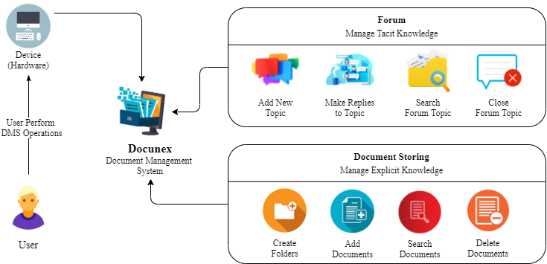

1. How Docunex is used in the company?

SS and demo

1. Benefits of Docunex

* Improves organizational identity.
* Greater clarity for employees and project clients regarding the program process.
* Improves communication across the company.
* Facilitate to improve the knowledge in areas that lead to organizational success.
* Reduced repeating the same work and manage organizational costs.

1. Conclusion

* Knowledge is the organization’s critical survival factor.
* Knowledge Management systems enhances the individual’s knowledge perspectives and business values that directs to organizational success to cope with the business competitors.
* To drive Nexie Labs towards business competition, Docunex, the component of Document Management System has been implemented.
* With this implementation, the company would organize and plan the KM activities based on their necessities and practices to boost out the productivity of the organization.